**EyeQ DG Diagnostics:**

EyeQ DG functionality performing below diagnostic checks , the logs the fault if there is any failure.

* Sync Frame index Check
* Message Timeout Check
* Missing Message check
* Crc Diagnostics check

**Chap 1**

There are many messages are coming from Mobileye chip and they are categories as Object,Lane,…, for each message there will be diagnostic check.

For each message, files are created in \Application\Core_Comp\CDD\EyeQ_CDD\EyeQ_DG\src

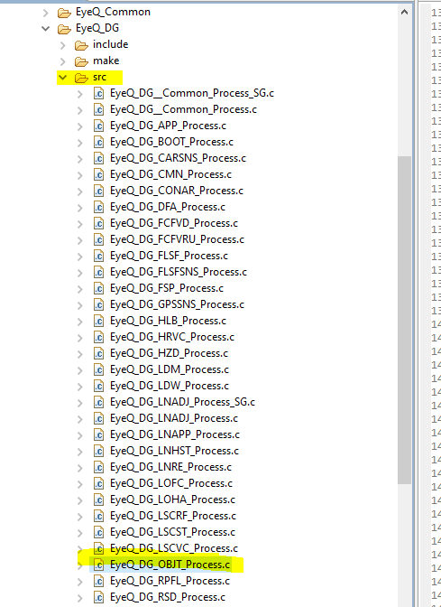

Consider an example of an Object information for that “EyeQ_DG_OBJT_Process.c”

Whatever Object related signal present in Jupiter/norma sheet each signal is handled here

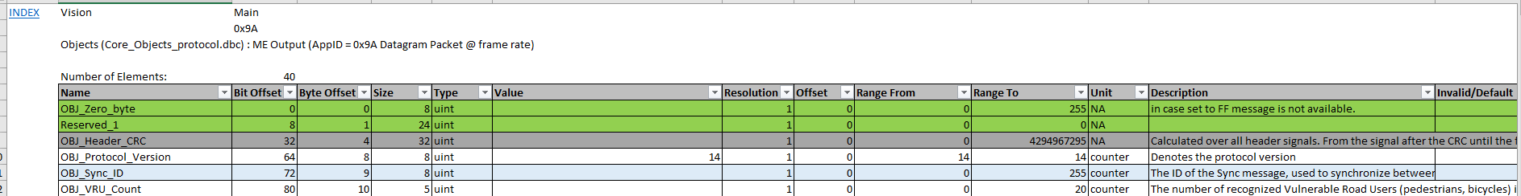

When application (EyeQWrapper,….) need any signal information then it is calling function inside(EyeQ_DG_OBJT_Process.c) this.

Suppose application need information regarding **OBJ_Inv_TTC_V** then it is calling to function **EYEQDG_Get_OBJT_OBJ_Inv_TTC_V** ,it send address of application variable



Then this application variable data filled with core application buffer variable “EYEQDG_OBJT_ParamsApp_s” as shown in below diagram

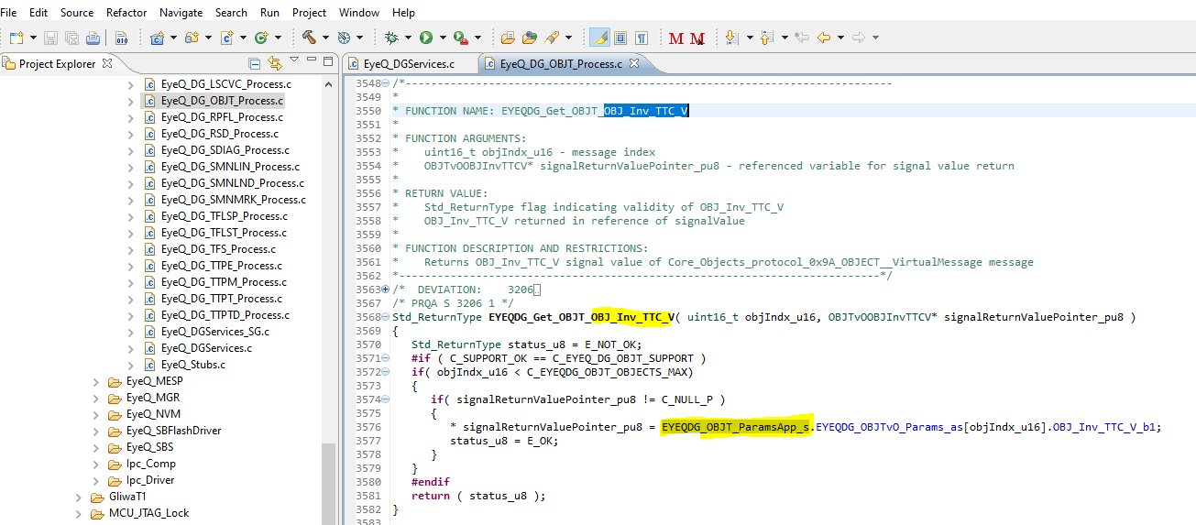

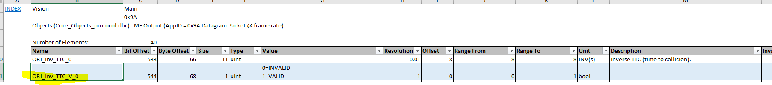

But who will fill this application core buffer “EYEQDG_OBJT_ParamsApp_s” we will see further.

**Chap 2**

Application core buffer “EYEQDG_OBJT_ParamsApp_s” which is using by application SWC component will filled by EYEQDG_OBJT_Params_s

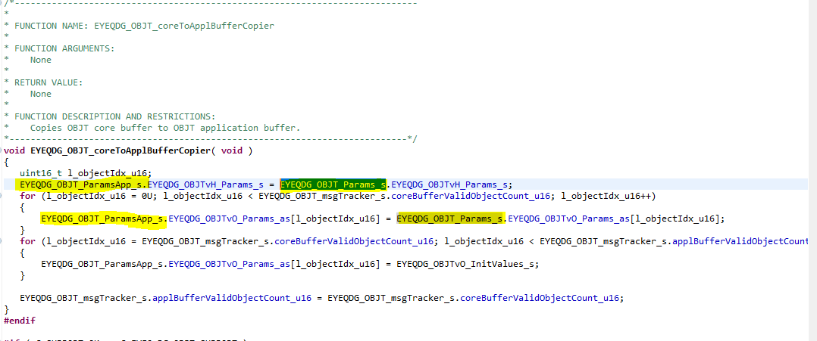

In above image

1. Application core buffer filled with Header part

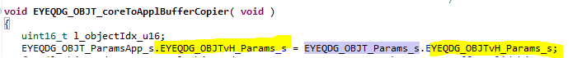

1. Application core buffer filled with Object part



1. 2nd for loop is for safe check ,is that all data filled

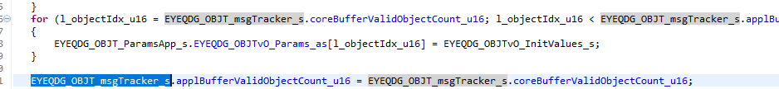

By seeing above code it is understand that initially data get into core buffer EYEQDG_OBJT_Params_s and then it is giving to application core buffer EYEQDG_OBJT_ParamsApp_s

So how core buffer EYEQDG_OBJT_Params_s will get update this we will check into next chapter.

**Chap 3**

In IPC_User.c file we are giving the address of Core buffer EYEQDG_OBJT_Params_s ,in this address camera Received data filled

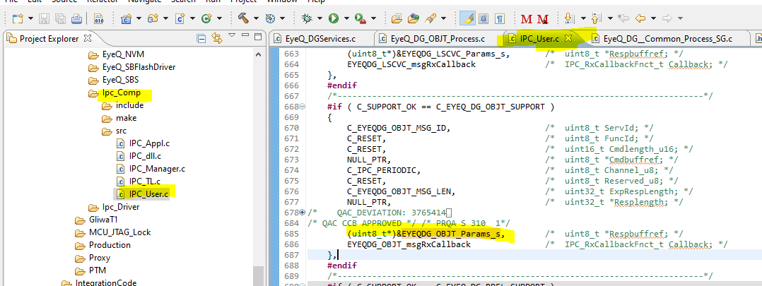

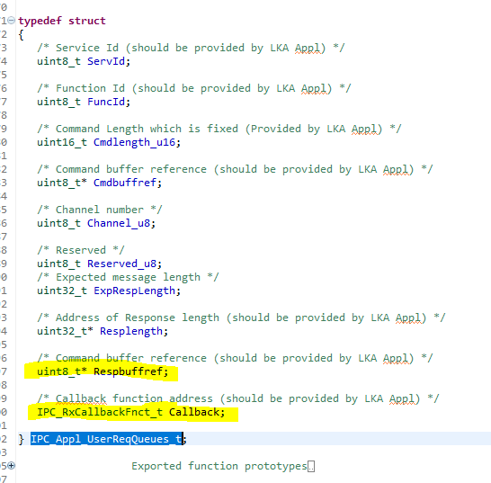

Once the data filled call back function also called, in this case **EYEQDG_OBJT_msgRxCallback**

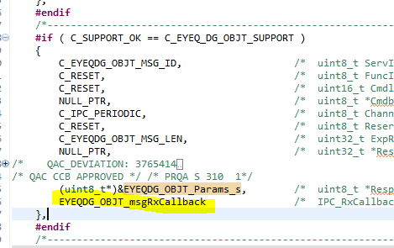

This call back function located in “EyeQ_DG__Common_Process.c” file where all message related information updated like

1. Updates OBJT message tracker after new message is received
2. Update number of messages received
3. Confirm that correct number of objects are received
4. NOTIFY_MASK

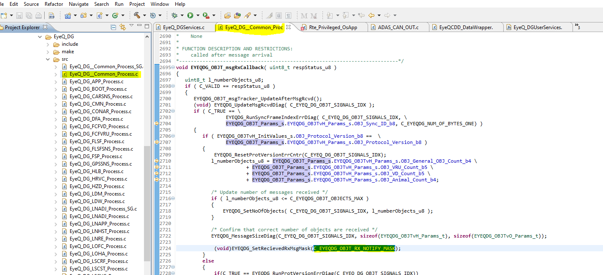

This NOTIFY_MASK confirms that message is received and this MASK we are checking in eyeq wrapper before process to message. If MASK is OK then we are checking CRC,if it is applicable

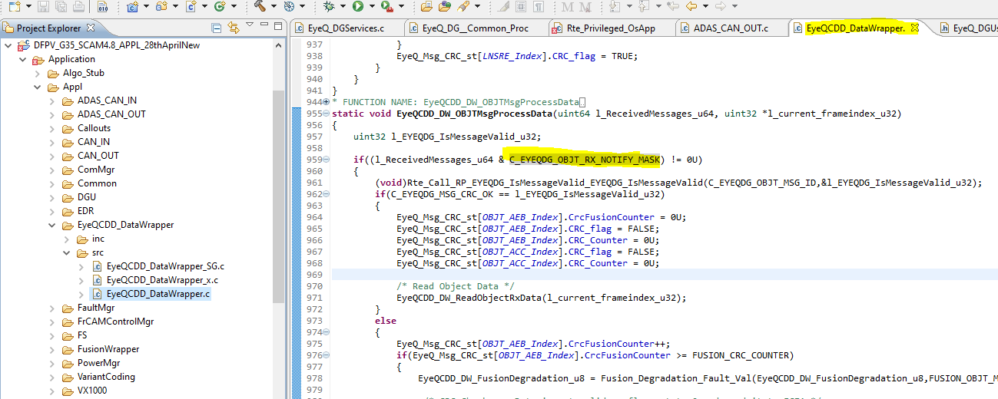

If any message related fault, then it is also set in this function.

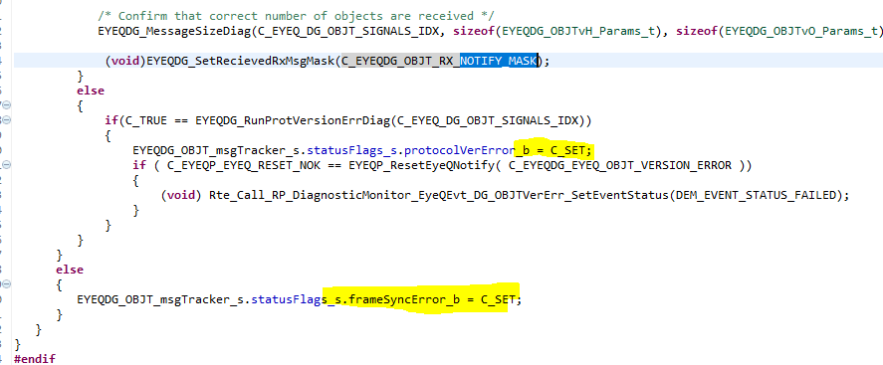

**Chap 4**

**CRC Check**

For those messages CRC applicable is mentioned in “EyeQ_DGServices.c” file

Consider object message

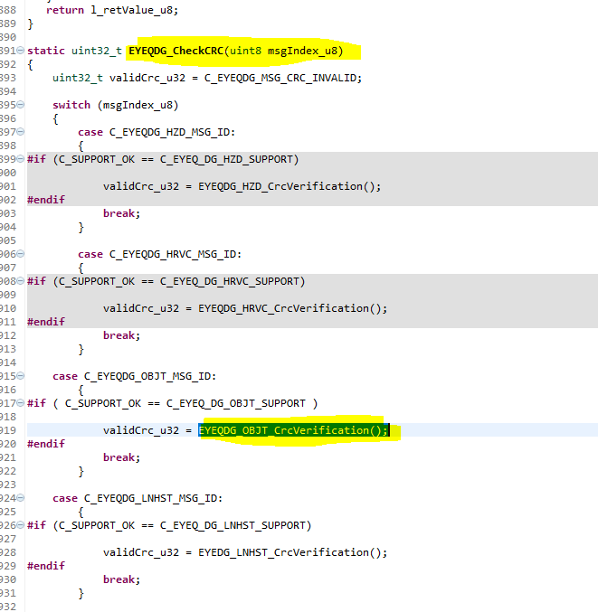

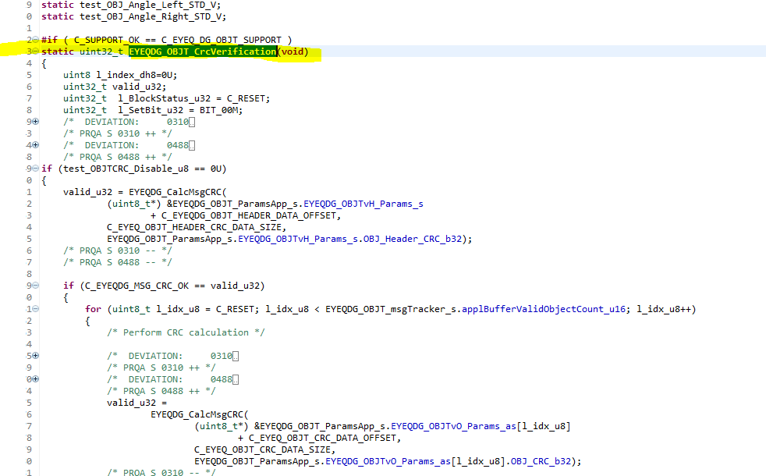

And this CRC function is called inside function **EYEQDG_IsMessageValid**

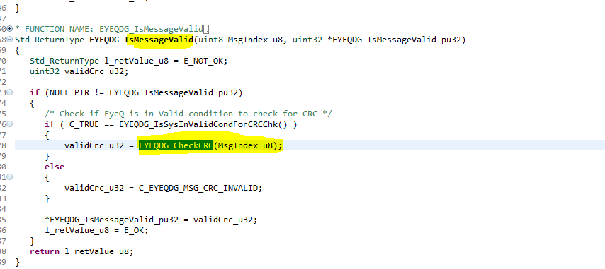

So to process any message in eyeq wrapper we are calling to function **EYEQDG_IsMessageValid**

to check CRC is valid or not.

If YES then we read signals and

If NO then we set CRC fail and doing further action.

Check below image for the same.

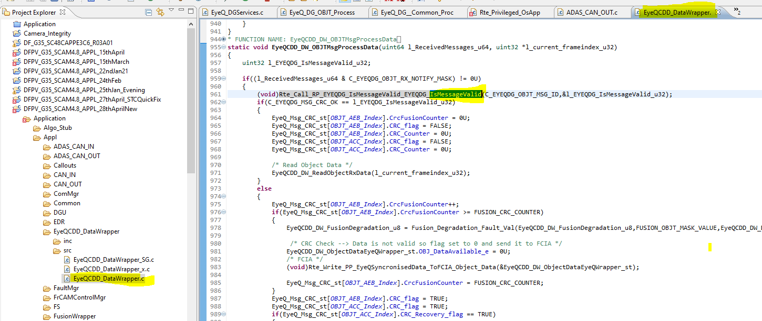

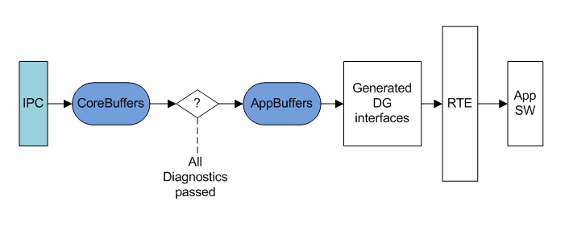

Figure 15 Core and Application buffer interaction

IPC uses core buffers to store Information sent/received from EyeQ. After receiving message from EyeQ IPC will process the message and copies the information to Core buffers. Once all diagnostics passed and data is ready to use by application software, the content of Core buffers will be copied into Application buffers. These Application buffers are used by EyeQ_DG module. The content of Application buffers will be exchnaged through generated DG interfaces with Application software.

* **Useful variable during release activity (integration test)**

1. **EYEQP_SystemMainState_u8**

#define C_EYEQSYSS_SYSTEM_STARTUP_STATE ( 2U )

#define C_EYEQSYSS_SYSTEM_NORMAL_STATE ( 3U )

#define C_EYEQSYSS_SYSTEM_TEMP_UNAVAILABLE_STATE ( 4U )

#define C_EYEQSYSS_SYSTEM_SAFE_STATE ( 5U )

#define C_EYEQSYSS_SYSTEM_UNAVAILABLE_STATE ( 6U )

#define C_EYEQSYSS_SYSTEM_SHUTDOWN_STATE ( 7U )

#define C_EYEQSYSS_NUMBER_OF_SYSTEM_STATES ( 8U )

1. **EYEQS_CurrentMainState_u8**

#define C_EYEQBS_EYEQ_MAIN_STATE_UNKNOWN ( 0x00U )

#define C_EYEQBS_EYEQ_MAIN_STATE_PENDING ( 0x01U )

#define C_EYEQBS_EYEQ_MAIN_STATE_BOOT ( 0x03U )

#define C_EYEQBS_EYEQ_MAIN_STATE_PENDING_DV ( 0x85U )

#define C_EYEQBS_EYEQ_MAIN_STATE_RUNNING_APP_BURN ( 0xAAU )

#define C_EYEQBS_EYEQ_MAIN_STATE_PENDING_VISION ( 0x92U )

#define C_EYEQBS_EYEQ_MAIN_STATE_VISION ( 0x02U )

#define C_EYEQBS_EYEQ_MAIN_STATE_PENDING_SPC ( 0x82U )

#define C_EYEQBS_EYEQ_MAIN_STATE_RUNNING_SPC ( 0x22U )

#define C_EYEQBS_EYEQ_MAIN_STATE_PENDING_SPTAC ( 0x81U )

#define C_EYEQBS_EYEQ_MAIN_STATE_RUNNING_SPTAC ( 0x21U )

#define C_EYEQBS_EYEQ_MAIN_STATE_PENDING_TAC ( 0x80U )

#define C_EYEQBS_EYEQ_MAIN_STATE_RUNNING_TAC ( 0x20U )

#define C_EYEQBS_EYEQ_MAIN_STATE_PENDING_TAC2 ( 0xABU )

#define C_EYEQBS_EYEQ_MAIN_STATE_RUNNING_TAC2 ( 0xACU )

#define C_EYEQBS_EYEQ_MAIN_STATE_PENDING_SFR ( 0x83U )

#define C_EYEQBS_EYEQ_MAIN_STATE_RUNNING_SFR ( 0xB0U )

#define C_EYEQBS_EYEQ_MAIN_STATE_PENDING_SP ( 0x89U )

#define C_EYEQBS_EYEQ_MAIN_STATE_RUNNING_SP ( 0xAEU )

#define C_EYEQBS_EYEQ_MAIN_STATE_RUNNING_STEREO ( 0xAFU )

#define C_EYEQBS_EYEQ_STATE_UNAVAILBLE ( 0xFFU )

1. **EyeQ_RestartAttemptCnt_u16**
2. **EyeQLastResetSource_u8**
3. **EYEQS_CurrentSubState_u8**
4. **#define** C_EYEQSYSS_SYSTEM_SUBSTATE_CORESYSSTART_INIT ( 0x00U )
5. **#define** C_EYEQSYSS_SYSTEM_SUBSTATE_CORESYSSTART_FAILURE ( 0x0EU )
6. **#define** C_EYEQSYSS_SYSTEM_SUBSTATE_CORESYSSTART_SUCCESS ( 0x0FU )
7. **#define** C_EYEQSYSS_SYSTEM_SUBSTATE_PWRVISION_INIT ( 0x10U )
8. **#define** C_EYEQSYSS_SYSTEM_SUBSTATE_PWRVISION_FAILURE ( 0x1EU )
9. **#define** C_EYEQSYSS_SYSTEM_SUBSTATE_PWRVISION_SUCCESS ( 0x1FU )
10. **#define** C_EYEQSYSS_SYSTEM_SUBSTATE_SBS_INIT ( 0x20U )
11. **#define** C_EYEQSYSS_SYSTEM_SUBSTATE_SBS_HASHCALCULATION ( 0x21U )
12. **#define** C_EYEQSYSS_SYSTEM_SUBSTATE_SBS_SIGNATUREVERIFICATION ( 0x22U )
13. **#define** C_EYEQSYSS_SYSTEM_SUBSTATE_SBS_FAILURE ( 0x2EU )
14. **#define** C_EYEQSYSS_SYSTEM_SUBSTATE_SBS_SUCCESS ( 0x2FU )
15. **#define** C_EYEQSYSS_SYSTEM_SUBSTATE_SUSD_INIT ( 0x30U )
16. **#define** C_EYEQSYSS_SYSTEM_SUBSTATE_SUSD_BIST ( 0x31U )
17. **#define** C_EYEQSYSS_SYSTEM_SUBSTATE_SUSD_BOOTAUTHENTICATION ( 0x32U )
18. **#define** C_EYEQSYSS_SYSTEM_SUBSTATE_SUSD_DDRINIT ( 0x33U )
19. **#define** C_EYEQSYSS_SYSTEM_SUBSTATE_SUSD_APPLICATIONAUTHENTICATION ( 0x34U )
20. **#define** C_EYEQSYSS_SYSTEM_SUBSTATE_SUSD_APPMODEPENDING ( 0x35U )
21. **#define** C_EYEQSYSS_SYSTEM_SUBSTATE_SUSD_DDRTEST1 ( 0x36U )
22. **#define** C_EYEQSYSS_SYSTEM_SUBSTATE_SUSD_DDRTEST2 ( 0x37U )
23. **#define** C_EYEQSYSS_SYSTEM_SUBSTATE_SUSD_DDRTESTFAILURE ( 0x38U )
24. **#define** C_EYEQSYSS_SYSTEM_SUBSTATE_SUSD_DDRTESTSUCCESS ( 0x39U )
25. **#define** C_EYEQSYSS_SYSTEM_SUBSTATE_SUSD_WAITINGHOTRESTART ( 0x3BU )
26. **#define** C_EYEQSYSS_SYSTEM_SUBSTATE_SUSD_DDRTEST_INIT_FAILURE ( 0x3CU )
27. **#define** C_EYEQSYSS_SYSTEM_SUBSTATE_SUSD_FAILURE ( 0x3EU )
28. **#define** C_EYEQSYSS_SYSTEM_SUBSTATE_SUSD_SUCCESS ( 0x3FU )
29. **#define** C_EYEQSYSS_SYSTEM_SUBSTATE_SUSD_SPIINITFAILURE ( 0x40U )
30. **#define** C_EYEQSYSS_SYSTEM_SUBSTATE_EYEQ_SWITCH_SOFT_REBOOT ( 0x50U )
31. **#define** C_EYEQSYSS_SYSTEM_SUBSTATE_EYEQ_SWITCH_HARD_REBOOT ( 0x51U )/* System Substates During Shutdown */
32. **#define** C_EYEQSYSS_SYSTEM_SUBSTATE_SHUTDOWN_FIRSTDDRTEST ( 1U )
33. **#define** C_EYEQSYSS_SYSTEM_SUBSTATE_SHUTDOWN_SECONDDDRTEST ( 2U )
34. **#define** C_EYEQSYSS_SYSTEM_SUBSTATE_SHUTDOWN_FINISHED ( 3U )
35. **#define** C_EYEQSYSS_SYSTEM_SUBSTATE_APPLICATION_TURN_OFF_EYEQ_REQUEST_SUCCESS ( 4U )
36. **EYEQP_CurrentErrorStatus_u32**

/****************** EyeQ Error code Table Start ***************/

1. **#define** C_EYEQDG_EYEQ_NO_ERRORCODE ( 0x00U )
2. **#define** C_EYEQDG_EYEQ_VIDEOMSG_TIMEOUT ( 0x01U )
3. **#define** C_EYEQDG_EYEQ_VEH_MSG_TIMEOUT ( 0x02U )
4. **#define** C_EYEQDG_APPLICATION_SHUTDOWN_REQUEST ( 0x03U )
5. **#define** C_EYEQDG_SWITCH_APPLICATION_MODE_TRANSITION ( 0x04U )
6. **#define** C_EYEQDG_APPLICATION_TURN_OFF_EYEQ_REQUEST ( 0x05U )

/************************ Free slots **************************/

1. **#define** C_EYEQDG_EYEQ_CARSNS_SIGNAL_INTEGRITY_ERR ( 0x07U )

/************************ Free slots **************************/

1. **#define** C_EYEQDG_EYEQ_CMN_CRC_ERROR ( 0x09U )
2. **#define** C_EYEQDG_EYEQ_CAM_INIT_ERR ( 0x10U )
3. **#define** C_EYEQDG_EYEQ_I2C_TIMEOUT_ERR ( 0x11U )
4. **#define** C_EYEQDG_EYEQ_APPDIAG_VERIFIERS_ERROR ( 0x12U )
5. **#define** C_EYEQDG_EYEQ_FFS_INTGT_FAILURE ( 0x13U )
6. **#define** C_EYEQDG_EYEQ_DDR_CHIP_FAILURE ( 0x14U )
7. **#define** C_EYEQDG_EYEQ_FLASH_MEM_FAILURE ( 0x15U )
8. **#define** C_EYEQDG_EYEQ_APP_ERR_FAULT ( 0x16U )
9. **#define** C_EYEQDG_EYEQ_APP_INIT_ERR_FAULT ( 0x17U )
10. **#define** C_EYEQDG_EYEQ_BIST_FAILURE ( 0x18U )
11. **#define** C_EYEQDG_EYEQ_TFLSP_VERSION_ERROR ( 0x19U )
12. **#define** C_EYEQDG_EYEQ_CAL_ERROR ( 0x1AU )
13. **#define** C_EYEQDG_EYEQ_CAM_SELF_RESET ( 0x1BU )
14. **#define** C_EYEQDG_EYEQ_IPC_SET_INIT_CAL_ERR ( 0x1CU )
15. **#define** C_EYEQDG_EYEQ_IPC_DTP_ERR ( 0x1DU )
16. **#define** C_EYEQDG_EYEQ_IPC_DEAD ( 0x1EU )
17. **#define** C_EYEQDG_EYEQ_SYS_VERIFI_REQ_ERROR ( 0x1FU )
18. **#define** C_EYEQDG_EYEQ_SYS_VERIFI_REQ_TRW_ERROR ( 0x20U )
19. **#define** C_EYEQDG_EYEQ_MESSAGE_SIZE_MISMATCH ( 0x21U )
20. **#define** C_EYEQDG_EYEQ_CMN_VERSION_ERROR ( 0x22U )
21. **#define** C_EYEQDG_EYEQ_TFS_VERSION_ERROR ( 0x23U )
22. **#define** C_EYEQDG_EYEQ_SAFETY_MSG_CRC_ERROR ( 0x24U )
23. **#define** C_EYEQDG_EYEQ_FCFVD_VERSION_ERROR ( 0x25U )
24. **#define** C_EYEQDG_EYEQ_FCFVRU_VERSION_ERROR ( 0x26U )
25. **#define** C_EYEQDG_EYEQ_CONAR_VERSION_ERROR ( 0x27U )
26. **#define** C_EYEQDG_EYEQ_I2C_VIDEO_GRAB_FAILED ( 0x28U )
27. **#define** C_EYEQDG_EYEQ_PLL_FAILURE ( 0x29U )
28. **#define** C_EYEQDG_EYEQ_PARITY_FAILURE ( 0x2AU )
29. **#define** C_EYEQDG_EYEQ_DFA_VERSION_ERROR ( 0x2BU )
30. **#define** C_EYEQDG_EYEQ_FFS_CORRUPTED_ERR ( 0x2CU )
31. **#define** C_EYEQDG_EYEQ_TRW_SAFETY_CODE_CRC ( 0x2DU )
32. **#define** C_EYEQDG_EYEQ_TRW_SAFETY_IMG_GRAB_MISS ( 0x2EU )
33. **#define** C_EYEQDG_EYEQ_TRW_SAFETY_FCV_SIG_FFI ( 0x2FU )
34. **#define** C_EYEQDG_EYEQ_TRW_SAFETY_AEB_PARAM_FFI ( 0x30U )
35. **#define** C_EYEQDG_EYEQ_INCREMENT_SYNC_FRAME_ERROR ( 0x31U )
36. **#define** C_EYEQDG_EYEQ_PV_GENERAL_FAULT ( 0x32U )
37. **#define** C_EYEQDG_EYEQ_PV_VERIFICATION_FAULT ( 0x33U )
38. **#define** C_EYEQDG_EYEQ_PLL_COMPARISON_FAULT ( 0x34U )
39. **#define** C_EYEQDG_EYEQ_FLSF_VERSION_ERROR ( 0x35U )
40. **#define** C_EYEQDG_EYEQ_HLB_VERSION_ERROR ( 0x36U )
41. **#define** C_EYEQDG_EYEQ_LDM_VERSION_ERROR ( 0x37U )
42. **#define** C_EYEQDG_EYEQ_LDW_VERSION_ERROR ( 0x38U )
43. **#define** C_EYEQDG_EYEQ_LNADJ_VERSION_ERROR ( 0x39U )
44. **#define** C_EYEQDG_EYEQ_LNAPP_VERSION_ERROR ( 0x3AU )
45. **#define** C_EYEQDG_EYEQ_LNHST_VERSION_ERROR ( 0x3BU )
46. **#define** C_IPCDRV_SPI_PARTIAL_BYTE_FAILURE ( 0x3CU )
47. **#define** C_EYEQDG_EYEQ_LSCRF_VERSION_ERROR ( 0x3DU )
48. **#define** C_IPCDRV_SPI_BUFFER_MISALIGNMENT_ERROR ( 0x3EU )
49. **#define** C_EYEQDG_EYEQ_MISSING_MSG_ERROR ( 0x3FU )
50. **#define** C_EYEQDG_EYEQ_LSCST_VERSION_ERROR ( 0x40U )
51. **#define** C_EYEQDG_EYEQ_LSCVC_VERSION_ERROR ( 0x41U )
52. **#define** C_EYEQDG_EYEQ_CAM_PARAMS_CCFT_CRC_FAILED ( 0x42U )
53. **#define** C_EYEQDG_EYEQ_APP_GVPU_STATE_TERMINA ( 0x43U )
54. **#define** C_EYEQDG_EYEQ_APPLMSG_VERSION_ERROR ( 0x44U )
55. **#define** C_EYEQDG_EYEQ_OBJT_VERSION_ERROR ( 0x45U )
56. **#define** C_EYEQDG_EYEQ_MSG_TIMEOUT_INDICATION ( 0x46U )
57. **#define** C_EYEQDG_EYEQ_MODE_TRANSITION_ERROR ( 0x47U )
58. **#define** C_EYEQDG_BOARD_REVISION_MISMATCH_ERROR ( 0x48U )
59. **#define** C_EYEQDG_EYEQ_LOFC_VERSION_ERROR ( 0x49U )
60. **#define** C_EYEQDG_SAFETY_MSG_INPUT_CRC_MISMATCH ( 0x4AU )
61. **#define** C_EYEQDG_EYEQ_RPFL_VERSION_ERROR ( 0x4BU )
62. **#define** C_EYEQDG_EYEQ_RSD_VERSION_ERROR ( 0x4CU )
63. **#define** C_EYEQDG_EYEQ_SMNLIN_VERSION_ERROR ( 0x4DU )
64. **#define** C_EYEQDG_BOOT_UNSUPPORTED_EYEQ_VERSION ( 0x4EU )
65. **#define** C_EYEQDG_EYEQ_SMNLND_VERSION_ERROR ( 0x4FU )
66. **#define** C_EYEQDG_EYEQ_THERMAL_SHUTDOWN ( 0x50U )
67. **#define** C_EYEQDG_EYEQ_GPIO16_EYEQ_WARMUP_STATE ( 0x51U )
68. **#define** C_EYEQDG_EYEQ_GPIO16_EYEQ_CORE_DUMP ( 0x52U )
69. **#define** C_EYEQDG_EYEQ_SMNMRK_VERSION_ERROR ( 0x53U )
70. **#define** C_EYEQDG_EYEQ_MCD_CORE_DUMP_END ( 0x54U )
71. **#define** C_EYEQDG_EYEQ_MCD_DATA_READ_ERR ( 0x55U )
72. **#define** C_EYEQDG_EYEQ_SDIAG_VERSION_ERROR ( 0x56U )
73. **#define** C_EYEQDG_EYEQ_FSP_VERSION_ERROR ( 0x57U )
74. **#define** C_EYEQDG_EYEQ_HRVC_VERSION_ERROR ( 0x58U )
75. **#define** C_EYEQDG_EYEQ_IPC_ME_COMPATIBILITY ( 0x59U )
76. **#define** C_EYEQDG_EYEQ_IPC_ME_RESP_TIMEOUT ( 0x60U )
77. **#define** C_EYEQDG_EYEQ_IPC_RX_FCS_FAILURE ( 0x61U )
78. **#define** C_EYEQDG_EYEQ_IPC_RX_UNREG_PROT ( 0x62U )
79. **#define** C_EYEQDG_EYEQ_IPC_RX_UNREG_ID ( 0x63U )
80. **#define** C_EYEQDG_EYEQ_IPC_RX_FIRST_FRAME_ERR ( 0x64U )
81. **#define** C_EYEQDG_EYEQ_IPC_RX_RX_OVERRUN ( 0x65U )
82. **#define** C_EYEQDG_EYEQ_IPC_RX_FRAME_SEQ_ERROR ( 0x66U )
83. **#define** C_EYEQDG_EYEQ_IPC_APPL_BUFF_OVF ( 0x67U )
84. **#define** C_EYEQDG_EYEQ_IPC_GEN_ERR ( 0x68U )
85. **#define** C_EYEQDG_EYEQ_IPC_DRV_BUFF_OVF ( 0x69U )
86. **#define** C_EYEQDG_EYEQ_HZD_VERSION_ERROR ( 0x6AU )
87. **#define** C_EYEQDG_EYEQ_LNRE_VERSION_ERROR ( 0x6BU )
88. **#define** C_EYEQDG_EYEQ_LOHA_VERSION_ERROR ( 0x6CU )
89. **#define** C_EYEQDG_EYEQ_TFLST_VERSION_ERROR ( 0x6DU )
90. **#define** C_EYEQDG_EYEQ_POWER_VBAT_ERROR ( 0x6EU )
91. **#define** C_EYEQDG_EYEQ_POWER_1V0_ERROR ( 0x70U )
92. **#define** C_EYEQDG_EYEQ_POWER_1V1_ERROR ( 0x71U )
93. **#define** C_EYEQDG_EYEQ_POWER_1V5_ERROR ( 0x72U )
94. **#define** C_EYEQDG_EYEQ_POWER_1V8_ERROR ( 0x73U )
95. **#define** C_EYEQDG_EYEQ_POWER_1V3_ERROR ( 0X74U )
96. **#define** C_EYEQDG_EYEQ_POWER_3V3_ERROR ( 0x75U )
97. **#define** C_EYEQDG_EYEQ_POWER_5V0_ERROR ( 0x76U )
98. **#define** C_EYEQDG_EYEQ_POWER_VBAT_INIT_ERROR ( 0x77U )
99. **#define** C_EYEQDG_EYEQ_POWER_3V3_INIT_ERROR ( 0x78U )
100. **#define** C_EYEQDG_EYEQ_POWER_5V0_INIT_ERROR ( 0x79U )
101. **#define** C_EYEQDG_EYEQ_POWER_2V8_ERROR ( 0x7AU )
102. **#define** C_EYEQDG_EYEQ_POWER_1V2_ERROR ( 0X7BU )
103. **#define** C_EYEQDG_EYEQ_POWER_1V0_OFFLOAD_ERROR ( 0X7CU )
104. **#define** C_EYEQDG_EYEQ_POWER_1V1_OFFLOAD_ERROR ( 0X7DU )
105. **#define** C_EYEQDG_EYEQ_POWER_IMAGER_OFFLOAD_ERROR ( 0X7EU )
106. **#define** C_EYEQDG_EYEQ_POWER_1V8_OFFLOAD_ERROR ( 0X7FU )
107. **#define** C_EYEQDG_EYEQ_SFR_VERSION_ERROR ( 0x80U )
108. **#define** C_EYEQDG_EYEQ_DYN_CALIB_VERSION_ERROR ( 0x81U )
109. **#define** C_EYEQDG_EYEQ_SP_VERSION_ERROR ( 0x82U )
110. **#define** C_EYEQDG_EYEQ_TTPE_VERSION_ERROR ( 0x83U )
111. **#define** C_EYEQDG_EYEQ_SENS_MSG_TIMEOUT ( 0x84U )
112. **#define** C_EYEQDG_CALSTCMSG_MODE_ERROR ( 0x85U )
113. **#define** C_EYEQDG_CALSTCMSG_HDRCRC_ERROR ( 0x86U )
114. **#define** C_EYEQDG_CALSTCMSG_OBJCRC_ERROR ( 0x87U )
115. **#define** C_EYEQDG_CALSTCMSG_VERSION_ERROR ( 0x88U )
116. **#define** C_EYEQDG_EYEQ_BOOT_VERSION_ERROR ( 0x89U )
117. **#define** C_EYEQDG_EYEQ_TTPM_VERSION_ERROR ( 0x8AU )
118. **#define** C_EYEQDG_EYEQ_EDR_NOT_ESPRUNNING_ONTIME ( 0x8BU )
119. **#define** C_EYEQDG_VEHICLE_SIGS_INVALID ( 0x8CU )
120. **#define** C_EYEQDG_NVM_ERROR ( 0x90U )
121. **#define** C_EYEQDG_EYEQ_DYN_CALIB_CRC_HEADER_ERROR ( 0x91U )
122. **#define** C_EYEQDG_EYEQ_DYN_CALIB_CRC_OBJ_ERROR ( 0x92U )
123. **#define** C_EYEQDG_EYEQ_DYN_CALIB_WRONG_MODE_ERROR ( 0x93U )
124. **#define** C_EYEQDG_EYEQ_IPC_RX_FRAME_HDR_ERROR ( 0x94U )
125. **#define** C_EYEQDG_EYEQ_IPC_RX_FRAME_CRC_ERROR ( 0x95U )
126. **#define** C_EYEQDG_EYEQ_IPC_CONS_FRAME_NOT_RXED ( 0x96U )
127. **#define** C_EYEQDG_EYEQ_IPC_RX_IMPROPER_FRAME_SIZE ( 0x97U )
128. **#define** C_EYEQDG_EYEQ_IPC_INCOMPLETE_MULTFRM_ERR ( 0x98U )
129. **#define** C_EYEQDG_FLSF_HDRCRC_ERROR ( 0X99U )
130. **#define** C_EYEQDG_FLSF_OBJCRC_ERROR ( 0X9AU )
131. **#define** C_EYEQDG_EYEQ_TTPT_VERSION_ERROR ( 0x9BU )
132. **#define** C_EYEQDG_EYEQ_TTPTD_VERSION_ERROR ( 0x9CU )
133. **#define** C_EYEQDG_EYEQ_CAM_INIT_CAMERA_EEPROM ( 0x9DU )
134. **#define** C_EYEQDG_EYEQ_GRAB_CAMERA_FAILED ( 0x9EU )
135. **#define** C_EYEQDG_EYEQ_CPS_STL_FAIL ( 0x9FU )
136. **#define** C_EYEQDG_EYEQ_DDR_DRIFT_COMPARISON_FAIL ( 0xA0U )
137. **#define** C_EYEQDG_EYEQ_EDR_FLASH_FAIL ( 0xA1U )

/******************* Safety errors zone - Start ****************/

1. **#define** C_EYEQDG_FS_OOC_ERROR ( 0xA2U )
2. **#define** C_EYEQDG_EYEQ_INTERMITTENT_CNR_ERROR ( 0xA3U )
3. **#define** C_EYEQDG_SAFETY_BIT_SET ( 0xA4U )
4. **#define** C_EYEQDG_EYEQ_MISSING_FIRST_CNR_ERROR ( 0xA5U )
5. **#define** C_EYEQDG_EYEQ_CHALLENGE_ERROR ( 0xA6U )
6. **#define** C_EYEQDG_EYEQ_WRONG_CNR_ERROR ( 0xA7U )
7. **#define** C_EYEQDS_FS_MISALIGN_YAW_TIMEOUT_ERROR ( 0xA8U )
8. **#define** C_EYEQDS_FS_MISALIGN_PITCH_TIMEOUT_ERROR ( 0xA9U )
9. **#define** C_EYEQDS_FS_OOF_ERROR ( 0xAAU )
10. **#define** C_EYEQDG_SAFETY_LD_IND_SET ( 0xABU )
11. **#define** C_EYEQDG_SAFETY_VM_IND_SET ( 0xACU )
12. **#define** C_EYEQDG_SAFETY_PED_IND_SET ( 0xADU )
13. **#define** C_EYEQDG_SAFETY_BIT30_SET ( 0xAEU )

/************************ Free slots **************************/

1. **#define** C_EYEQDG_SAFETY_BIT36_SET ( 0xB0U )
2. **#define** C_EYEQDG_SAFETY_BIT39_SET ( 0xB1U )
3. **#define** C_EYEQDG_SAFETY_BIT42_SET ( 0xB2U )
4. **#define** C_EYEQDG_SAFETY_BIT43_SET ( 0xB3U )
5. **#define** C_EYEQDG_SAFETY_BIT45_SET ( 0xB4U )
6. **#define** C_EYEQDG_SAFETY_BIT48_SET ( 0xB5U )
7. **#define** C_EYEQDG_SAFETY_BIT51_SET ( 0xB6U )
8. **#define** C_EYEQDG_SAFETY_BIT52_SET ( 0xB7U )
9. **#define** C_EYEQDG_SAFETY_BIT4_SET ( 0xB8U )
10. **#define** C_EYEQDG_SAFETY_BIT6_SET ( 0xB9U )
11. **#define** C_EYEQDG_SAFETY_BIT7_SET ( 0xBAU )
12. **#define** C_EYEQDG_SAFETY_BIT9_SET ( 0xBBU )
13. **#define** C_EYEQDG_SAFETY_BIT18_SET ( 0xBCU )
14. **#define** C_EYEQDG_SAFETY_BIT24_SET ( 0xBDU )
15. **#define** C_EYEQDG_SAFETY_BIT25_SET ( 0xBEU )
16. **#define** C_EYEQDG_SAFETY_BIT26_SET ( 0xBFU )
17. **#define** C_EYEQDG_SAFETY_BIT27_SET ( 0xC0U )
18. **#define** C_EYEQDG_SAFETY_BIT31_SET ( 0xC1U )
19. **#define** C_EYEQDG_SAFETY_BIT34_SET ( 0xC2U )
20. **#define** C_EYEQDG_SAFETY_BIT35_SET ( 0xC3U )
21. **#define** C_EYEQDG_SAFETY_BIT37_SET ( 0xC4U )
22. **#define** C_EYEQDG_SAFETY_BIT38_SET ( 0xC5U )
23. **#define** C_EYEQDG_SAFETY_BIT40_SET ( 0xC6U )
24. **#define** C_EYEQDG_SAFETY_BIT44_SET ( 0xC7U )
25. **#define** C_EYEQDG_SAFETY_BIT47_SET ( 0xC8U )
26. **#define** C_EYEQDG_SAFETY_BIT49_SET ( 0xC9U )
27. **#define** C_EYEQDG_SAFETY_BIT50_SET ( 0xCAU )
28. **#define** C_EYEQDG_SAFETY_BIT53_SET ( 0xCBU )
29. **#define** C_EYEQDG_SAFETY_BIT54_SET ( 0xCCU )
30. **#define** C_EYEQDG_SAFETY_BIT11_SET ( 0xCDU )
31. **#define** C_EYEQDG_SAFETY_BIT13_SET ( 0xCEU )
32. **#define** C_EYEQDG_SAFETY_BIT21_SET ( 0xCFU )
33. **#define** C_EYEQDG_SAFETY_BIT29_SET ( 0xD0U )
34. **#define** C_EYEQDG_SAFETY_LD_EDGE_IND_SET ( 0xD1U )
35. **#define** C_EYEQDG_SAFETY_AEB_IND_SET ( 0xD2U )

/*************** Safety errors zone - End **********************/

1. **#define** C_EYEQDG_EYEQ_MSG_TIMEOUT ( 0xD3U )
2. **#define** C_EYEQDG_EYEQ_INVALID_REGION_CODE ( 0xD4U )
3. **#define** C_EYEQDG_INVALID_VEHICLE_SIGNALS_ERROR ( 0xD5U )
4. **#define** C_IOHWAB_PWMGR_BOARDREV_INVALID_ERROR ( 0xD6U )

/*****************SBS error****************************/

1. **#define** C_EYEQ_SBS_AUTHENTICATION_FAILED_ERROR ( 0xD7U )

/*****************ADC test error****************************/

1. **#define** C_IOHWAB_ADCDIAG_PULLDOWN_DIAG_ERROR ( 0xD8U )
2. **#define** C_IOHWAB_ADCDIAG_CONVERTER_ERROR ( 0xD9U )
3. **#define** C_IOHWAB_ADCDIAG_BROKEN_WIRE_ERROR ( 0xDAU )

/*****************ErrorOutPin error****************************/

1. **#define** C_IOHWAB_DIODIAG_FATAL_ERROR ( 0xDBU )
2. **#define** C_IOHWAB_DIODIAG_SHORT2GND_ERROR ( 0xDCU )
3. **#define** C_IOHWAB_DIODIAG_SHORT2HIGH_ERROR ( 0xDDU )
4. **#define** C_IOHWAB_DIODIAG_OVERTEMP_ERROR ( 0xDEU )

/*******************Thermistor Sensor Failure *****************/

1. **#define** C_IOHWAB_THERMISTOR_SENSOR_FAILURE ( 0XDFU )/*Aurix 2G Thermistor Sensor Failure*/

/************** Startup/Shutdown Error Zone - Start ***********/

1. **#define** C_EYEQDG_BOOT_TIMEOUT_BIST ( 0xE0U )
2. **#define** C_EYEQDG_BOOT_TIMEOUT_BOOTAUTH ( 0xE1U )
3. **#define** C_EYEQDG_BOOT_TIMEOUT_RAMINIT ( 0xE2U )
4. **#define** C_EYEQDG_BOOT_TIMEOUT_APPAUTH ( 0xE3U )
5. **#define** C_EYEQDG_BOOT_TIMEOUT_DDRTEST ( 0xE4U )
6. **#define** C_EYEQDG_BOOT_SEQUENCE_ERROR_BIST ( 0xE5U )
7. **#define** C_EYEQDG_BOOT_SEQUENCE_ERROR_BOOTAUTH ( 0xE6U )
8. **#define** C_EYEQDG_BOOT_SEQUENCE_ERROR_RAMINIT ( 0xE7U )
9. **#define** C_EYEQDG_BOOT_SEQUENCE_ERROR_APPAUTH ( 0xE8U )
10. **#define** C_EYEQDG_BOOT_SEQUENCE_ERROR_DDRTEST ( 0xE9U )
11. **#define** C_EYEQDG_BOOT_DDR_TEST_FIRST_FAILURE ( 0xEAU )
12. **#define** C_EYEQDG_BOOT_DDR_TEST_FAILURE ( 0xEBU )

/************************ Free Space **************************/

1. **#define** C_EYEQDG_BOOT_BOOT_AUTH_FAILURE ( 0xEDU )
2. **#define** C_EYEQDG_BOOT_APP_AUTH_FAILURE ( 0xEEU )
3. **#define** C_EYEQDG_BOOT_DDRTEST_INIT_FAILURE ( 0xEFU )/*DDR Initialization Failure*/

/************ Startup/Shutdown Error Zone - end ***************/

1. **#define** C_EYEQNVM_CORE_NVM_BLOCK_CRC_FAILED ( 0XF0U )
2. **#define** C_EYEQNVM_CORE_NVM_BLOCK_TAGID_FAILED ( 0XF1U )
3. **#define** C_IOHWABNVM_CORE_NVM_BLOCK_CRC_FAILED ( 0XF2U )
4. **#define** C_IOHWABNVM_CORE_NVM_BLOCK_TAGID_FAILED ( 0XF3U )
5. **#define** C_IOHWAB_AURIX_DIE_SENSOR_FAILURE ( 0XF4U )/*Aurix 2G Die Sensor Failure*/
6. **#define** C_IOHWAB_GPIO18_VERIFICATION_ERROR ( 0xF5U )
7. **#define** C_IOHWAB_CYPRESS_FLASH_FAIL ( 0xF6U )
8. **#define** C_EYEQDG_EYEQ_IPC_QSPI0_ERROR ( 0xF7U )/*IPCDRV QSPI Errors*/
9. **#define** C_EYEQDG_EYEQ_IPC_QSPI1_ERROR ( 0xF8U )
10. **#define** C_EYEQDG_EYEQ_IPC_QSPI2_ERROR ( 0xF9U )